**5.Class Diagram:**

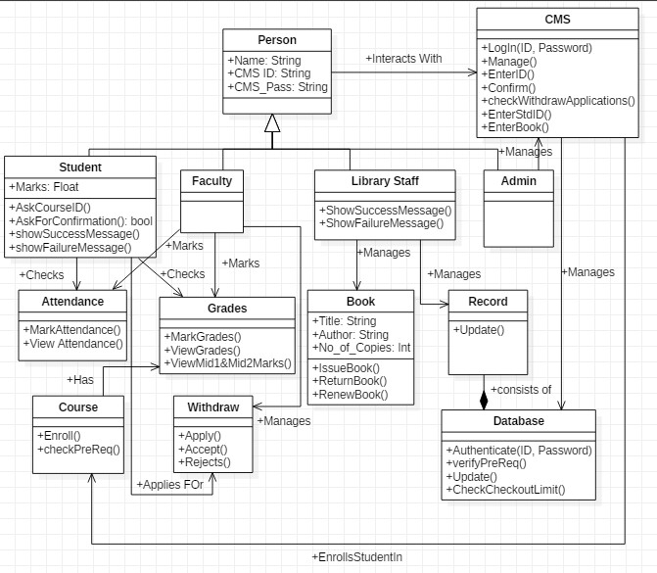

**6. Sequence Diagrams:**

* 1. **SD1 [Enroll Student]:**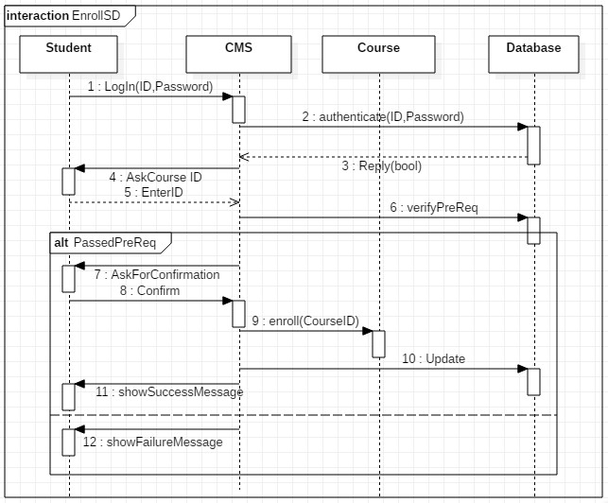
  2. **SD2 [Manage Withdraw Applications]:**

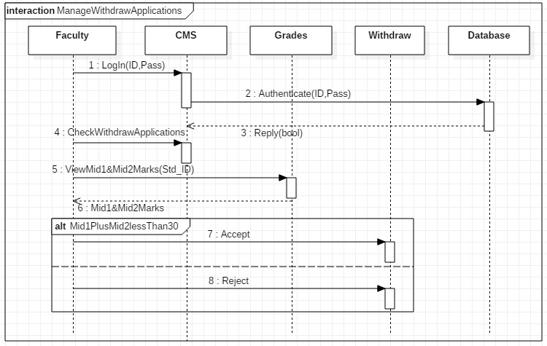

* 1. 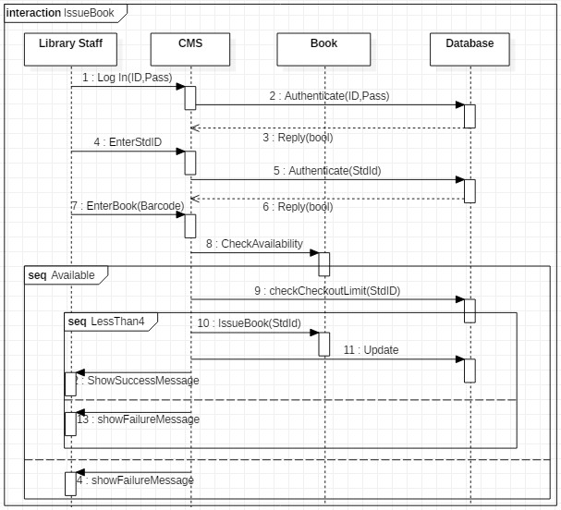**SD3 [Issue Book]:**

**7. Activity Diagrams:**

1. **AD1 [Enroll Student]:**

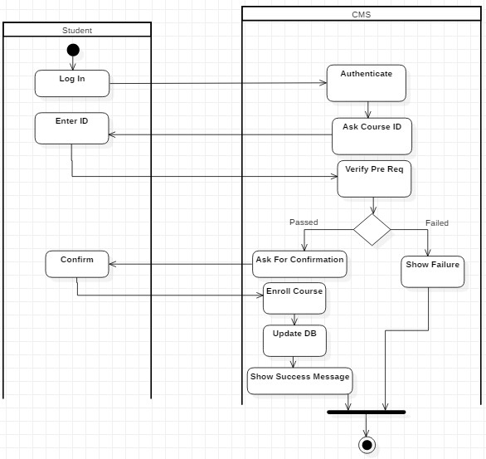

1. **AD2 [Manage Withdraw Applications]:**

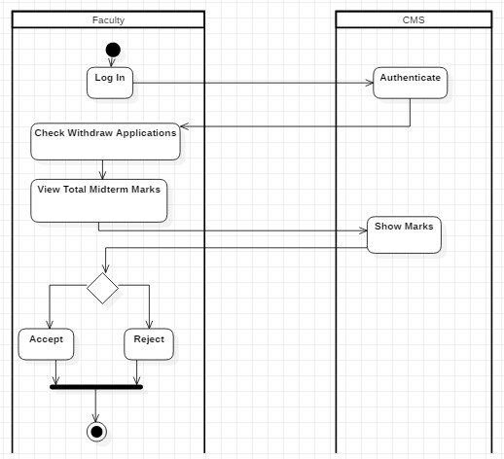

1. **AD3 [Issue Book]:**

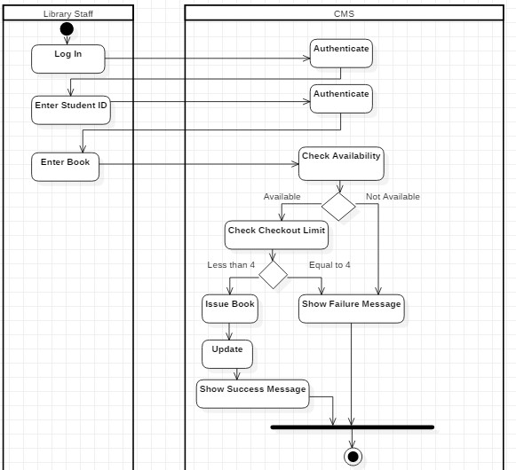

**8. State Machine Diagrams:**

1. **SMD1 [Book]:**

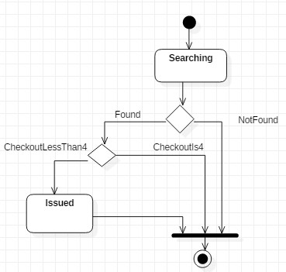

1. **SMD2 [Course]:**

